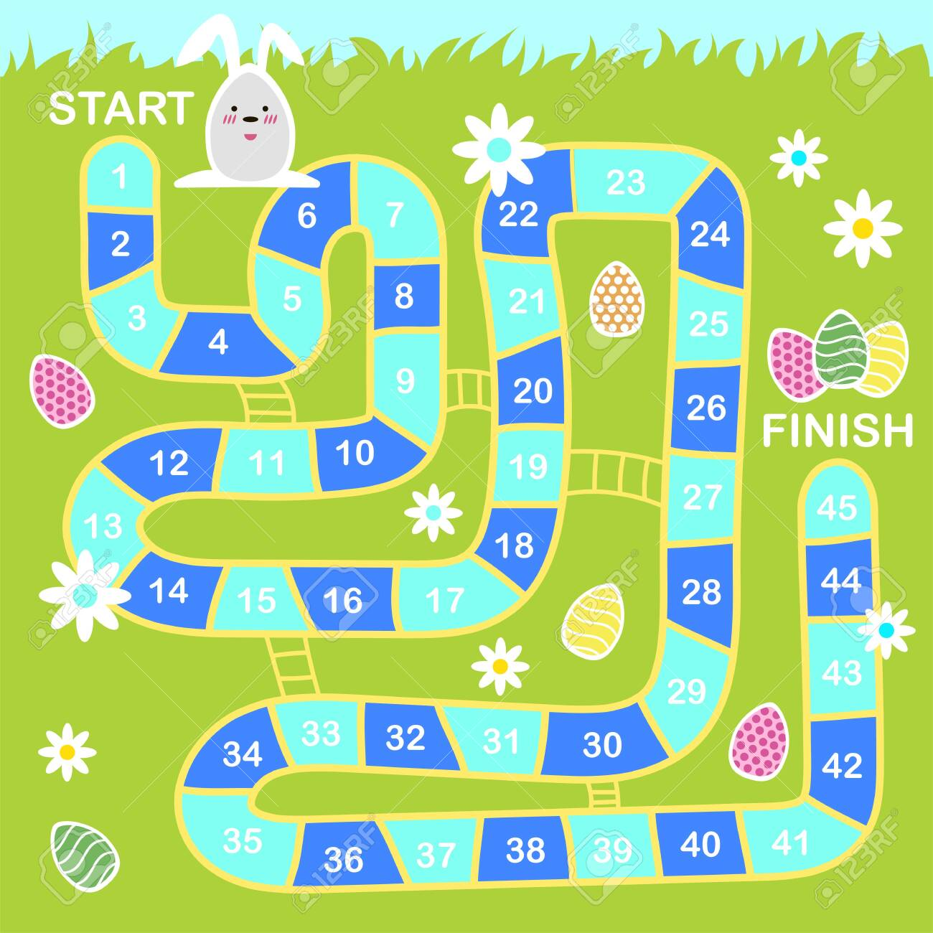
Spring Bunny Counting Board Game

